**Pre-laboratory Questions**

1. What limits the size of cells?(.5 point)

Surface area-to-volume ratio is what limits the size of the cell. If the cell becomes too large, the surface area will not be able to facilitate efficient exchange of materials.

1. What is a semi-permeable membrane?(.5 point)

A semi-permeable membrane is a membrane that determines what substances can and cannot pass through. It is like a bouncer at a bar.

1. What is diffusion? (.5 point)

Diffusion is the movement of molecules from an area of high concentration to an area of low concentration.

1. Differentiate between a solute, solvent and solution. (.5 point)

Solute: Substance that gets dissolved Solvent: Substance that does the dissolving Solution: The mixture you get when solute and solvent come together.

1. What influences the direction of the movement of water in osmosis? (.5 point)

Direction of the movement of water in osmosis is influenced by the concentration of solutes on either side of semi-permeable membrane.

1. List three differences between eukaryotic and prokaryotic cells. (.5 point)

Three differences between eukaryotic and prokaryotic cells are as follows: In the nucleus, eukaryotic cells have a nucleus; prokaryotic cells do not. Organelles can be found in eukaryotic cells, prokaryotic cells don’t. Finally size, eukaryotic cells are larger than prokaryotic cells.

1. What is a virus? (.5 point)

A virus is a small infectious agent that needs a host cell to replicate.

**Activity 1: Why Are Cells So Small?**

Fill in the data table below with the results of your experiment.

**Data Table 1**(1 point)

|  |  |  |  |  |  |
| --- | --- | --- | --- | --- | --- |
| length (*l) (cm)* | width (*w*)  (cm) | height (*h*)  (cm) | Size of cross section slice  (h x w) (cm) | Distance traveled  by I2KI  from potato edge (cm) | Area of white region  (l × w) (cm2) |
| 2.50 | 2.50 | 2.50 | 6.25 | 0.2 | 6.25cm^2 |
| 2.00 | 2.00 | 1.00 | 2.00 | 0.4 | 4.00cm^2 |
| 1.50 | 1.50 | 1.50 | 2.25 | 0.5 | 2.25cm^2 |
| 1.00 | 1.00 | 1.00 | 1.00 | 0.5 | 1.00cm^2 |
| 2.00 | 0.50 | 0.50 | 0.25 | 0.5 | 1.00cm^2 |
| 0.50 | 0.50 | 0.50 | 0.25 | 0.5 | 0.25cm^2 |

Fill in the data table below with the results of your experiment. **Data Table 2**(1 point)

|  |  |  |  |  |  |  |  |  |  |
| --- | --- | --- | --- | --- | --- | --- | --- | --- | --- |
| length (*l*) | width (*w*) | height (*h*) | surface area of block (*l* x *w* x 2) + (*w* x *h*\*4) (cm2) | volume *(l* x *w* x *h*) (cm3) | surface area/volume | surface area of slice  (*w* x *h*) (cm2) | surface area of white section (cm2) | surface area of black section (cm2) | Surface area of black section/surface area of slice |
| 2.50 | 2.50 | 2.50 | 37.5 | 15.63 | 2.40 | 6.25 | 5.29 | 0.96 | 10% |
| 2.00 | 2.00 | 1.00 | 16 | 4.0 | 4.0 | 4.0 | 2.72 | 1.28 | 30% |
| 1.50 | 1.50 | 1.50 | 13.5 | 3.38 | 4.0 | 2.25 | 1.16 | 1.09 | 25% |
| 1.00 | 1.00 | 1.00 | 6 | 1 | 6.0 | 1.0 | 0.30 | 0.70 | 90% |
| 0.50 | 0.50 | 2.00 | 4.5 | 0.5 | 9.0 | 1.0 | 0.28 | 0.72 | 75% |
| 0.50 | 0.50 | 0.50 | 1.5 | 0.13 | 11.54 | 0.25 | 0.0 | 0.25 | 80% |

**Activity 1 Image: Results of Why Are Cells So Small, Step 5**

## Image (2 points)

A required part of this laboratory experiment is to capture pictures of the experimental process and results. Click on the icon in the box below to include the required image for this lab.

**Note:** Failure to submit these images will result in a grade of zero for this lab.

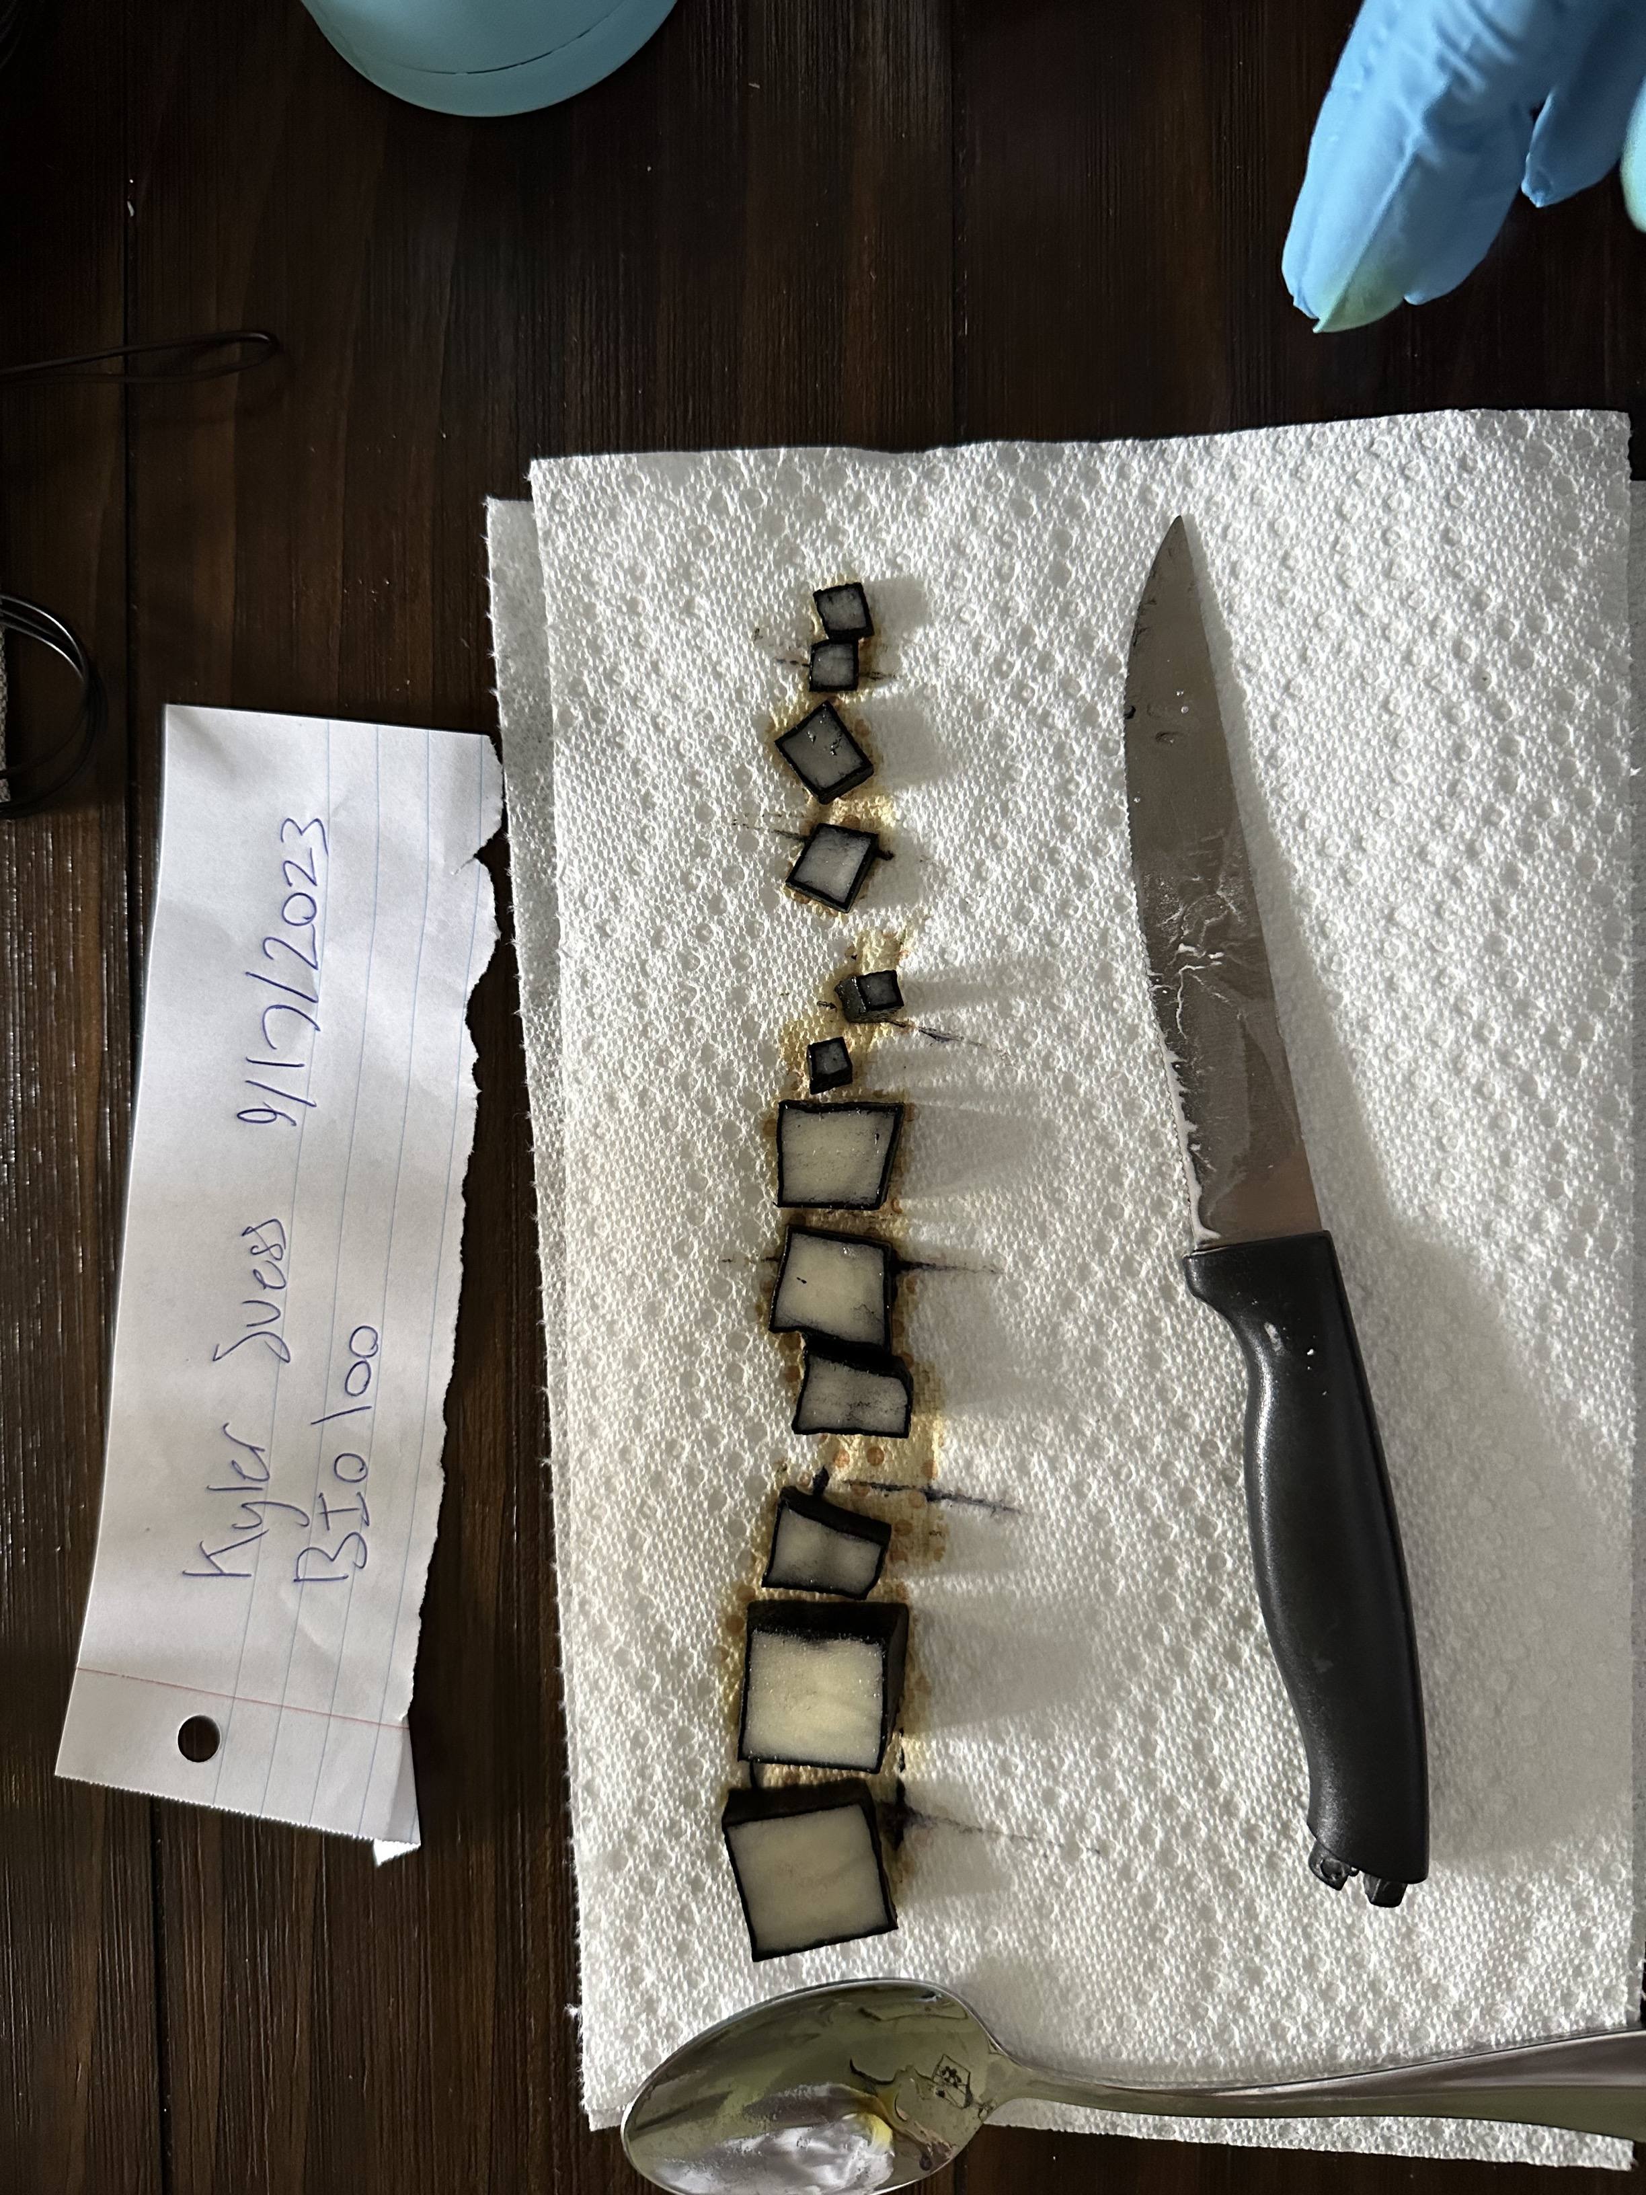

Results for Activity 1, Step5

**Laboratory Questions**

**Activity 1**

1. The potato blocks used in this experiment are comprised of starch molecules. Iodine potassium iodide is a starch indicator that forms a blue-black complex in the presence of starch. What does the width of the black of the potato cube represent in the context of diffusion? (1 point)

*The width of the black region in the potatoes represents the area where the iodine potassium iodine has not diffused. This turns starch molecules black, so it shows where the solution hasn’t reached. This indicated the limit of diffusion.*

1. How does the width of the black of each potato block compare to the others? Why? (1 point)

*The more surface area there was, the less efficiently the iodine was diffused. Smaller potatoes showed more black meaning the iodine was able to diffuse more efficiently where as the larger potatoes wasn’t able to penetrate beyond a certain point.*

1. What implications do the results have for diffusion into a cell? In other words, why are cells small? (1 point)

*Cells are small so they optimize the efficiency of diffusion. If cells were too large, the center might not receive adequate nutrients or be able to expel waste effectively. This is what happened with the potatoes. The potatoes represented different cell sizes.*

**Activity 2: Cell Membranes, Osmosis and Diffusion**

Fill in the data table below with the results of your experiment.

**Example Data Table 3** (1 point)

|  |  |  |  |  |  |  |  |
| --- | --- | --- | --- | --- | --- | --- | --- |
| Treatment | Solution in Dialysis Tubing | Solution in Cup | Initial Mass (Vi) (mL) | Final Mass (Vf) (mL) | Change in Volume (Vf-Vi) (mL) | Percent Change in Volume (Vf-Vi)/Vi (mL) | Hypotonic, Isotonic  or Hypertonic? |
| A | 20% sucrose | 20% sucrose | 90 | 93 | 3 | 3% | Hyoptonic |
| B | 40% sucrose | 20% sucrose | 90 | 90 | 0 | 0% | Isotonic |
| C | 20% sucrose | 40% sucrose | 90 | 89 | 1 | 1%% | Hypertonic |

**Activity 2 Image: Preparing the Dialysis Bags, Tubes A, B, & C, Step 11**

## Image (2 points)

A required part of this laboratory experiment is to capture pictures of the experimental process and results. Click on the icon in the box below to include the required image for this lab.

**Note:** Failure to submit these images will result in a grade of zero for this lab.

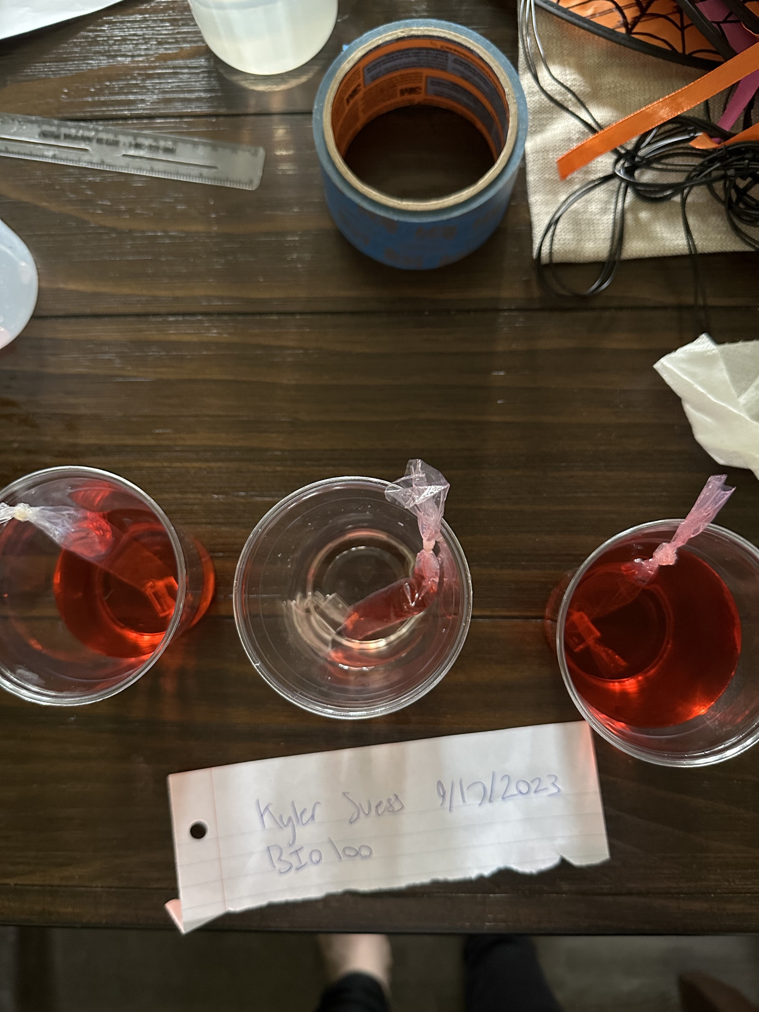

Activity 2: Preparing the Dialysis Bags Tubes A, B, & C, Step11

**Laboratory Questions**

**Activity 2**

1. Explain what the change in mass of the dialysis tube indicated. Describe what happened when the mass increased and when the mass decreased. (1 point)

The change in mass of the dialysis tube indicated that the solution was either hypertonic or hypotonic. Since cells strive for a balance, if the water left the tube, it tell us the solution inside the tube has a lower solute concentration compared to the surrounding solution.

1. When placed in 20% sucrose solution, how did the change in mass of the dialysis tubing containing 20% sucrose differ from the change in mass of the dialysis tubing containing 40% sucrose? Why is there a difference? (1 point)

I believe I have conducted the experiment poorly, because in theory, the 20/40 sucrose should have been hypotonic and gained mass because water rushes in to dilute the higher concentration of sucralose.

1. Because dialysis tubing is semipermeable, smaller molecules can pass through it while larger molecules cannot, or do so less readily. On the basis of observations, describe the relative sizes of the food coloring and sucrose molecules. Explain your answer.(1 point)

Food coloring molecules seem to be smaller than sucrose molecules, which allowed for a slight change in color of the tube.

**Activity 3: Cell Types and Viruses**

**Activity 3 Image: Designing a Prokaryotic Cell, Step 8**

## Image (2 points)

A required part of this laboratory experiment is to capture pictures of the experimental process and results. Click on the icon in the box below to include the required image for this lab.

**Note:** Failure to submit these images will result in a grade of zero for this lab.

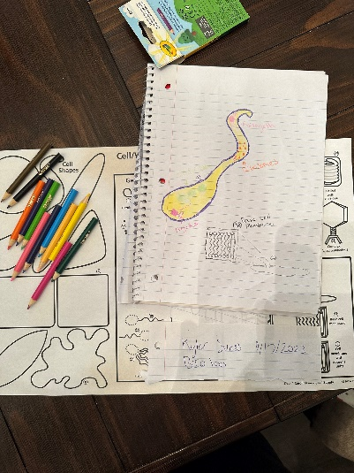

Activity 3: Designing a Prokaryotic Cell, Step 8

**Activity 3 Image: Designing a Eukaryotic Cell, Step 8**

## Image (2 points)

A required part of this laboratory experiment is to capture pictures of the experimental process and results. Click on the icon in the box below to include the required image for this lab.

**Note:** Failure to submit these images will result in a grade of zero for this lab.

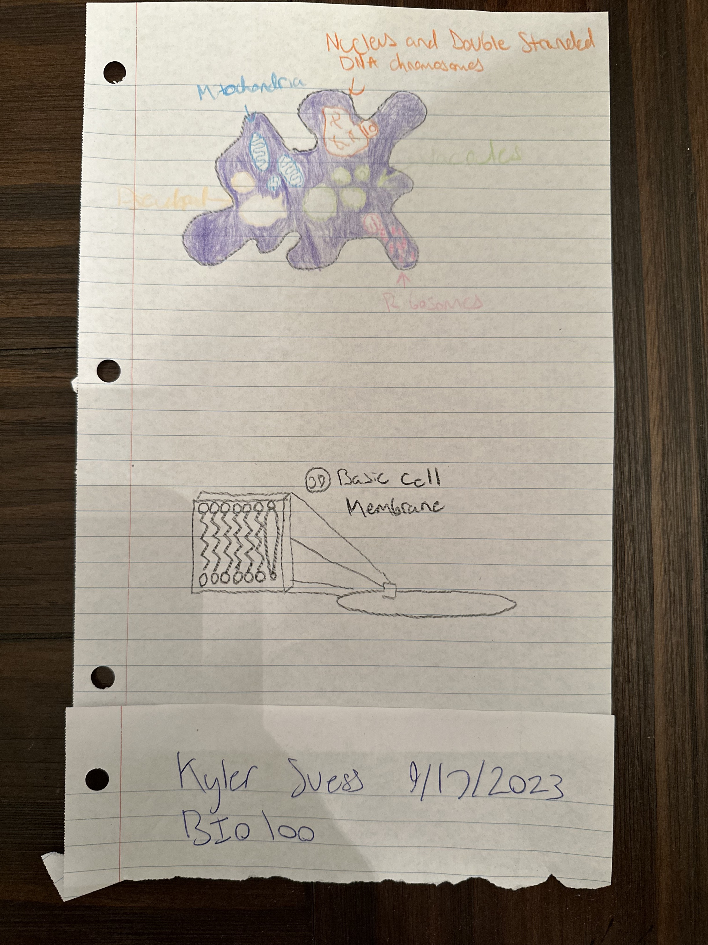

Activity 3: Designing a Eukaryotic Cell, Step 8

**Laboratory Questions**

**Activity 3**

1. Describe the prokaryotic cell that was designed, including its basic and special features. (.5 point)

I drewa prokaryotic cell with flagella, flagellum, ribosomes, cell wall, and cellular DNA.

1. Based on the cell components chosen, does the prokaryotic cell have any special abilities? (.5 point)

The cell would be able to move rapidly due to the multiple flagella.

1. Describe the eukaryotic cell that was designed, including its basic and special features. (.5 point)

The eukaryotic cell I drew had a basic cell membrane, mitochondria, nucleus and double stranded DNA chromosomes, vacuoles, ribosomes, and a pseudopod.

1. Based on the cell components chosen, does the eukaryotic cell have any special abilities? (.5 point)

The cell would be able to capture prey due to the pseudopod.

1. Describe the virus that was designed. (.5 point)

The virus I drew had a viral genome RNA, and was polyhedral.

1. Which have the most complex structure: eukaryotes, prokaryotes, or viruses? Which have the simplest structure? (.5 point)

Eukaryotes are the most complex

1. Use the Prokaryote Dichotomous Key to figure out which example cell is most similar to the cell that was designed. Explain. (1 point)

My prokaryote would be a Listeria monocytogenes because it has a basic cell membrane, is rod shaped, and has multiple flagella.

1. Use the Eukaryote Dichotomous Key to identify which example cell is most similar to the eukaryotic cell that was designed. Explain. (1 point)

The prokaryote I drew would be Amoeba or plasmodial slime because of the lack of a rigid shape and pseudopod.

1. Use the Virus Dichotomous Key to identify which example virus is most similar to the virus that was designed. Explain. (1 point)

My virus was a tick fever virus because of the polyhedral shape.

**LABORATORY REVIEW QUESTIONS**

1. Describe the major structural components of the cell membrane. (1 point)

The major structural components of the cell membrane are the phospholipid bilayer, protein channels, and cholesterol molecules

2. Match the method of membrane transport with its correct definition. (1 point)

D Simple Diffusion C Facilitated Diffusion

A Osmosis B Active Transport

a. The diffusion of water across a semipermeable membrane.

b. The energy-requiring process by which solutes are pumped from an area of lower concentration to an area of higher concentration with the help of transport proteins.

c. Solutes move across an area of higher concentration to an area of lower concentration with the help of transport proteins.

d. The movement of small, hydrophobic molecules across a membrane from an area of higher concentration to an area of lower concentration.

3. A red blood cell that contains 5% glucose is placed into a 10% glucose solution (1.5 points)

A. How would you classify the glucose solution (hypotonic, hypertonic or isotonic)?

Hypertonic

B. What is direction of osmotic movement (the movement of water)?

Water would move out of the cell.

C. What happens to the shape of the red blood cell?

The red blood cell would shrink

4. What are major structural differences between plant and animal cells? (1 point)

Plant cells have cell walls, chloroplasts, and a large central vacuole, while animals cells do not.

5. In the past, a method for preserving meat, such as pork, without refrigeration has been to cover it with salt and spices. How does the process of curing meat with salt help prevent spoilage? (1 points)

Salt acts as a desiccant and creates a hypertonic environment that inhibits the growth of bacteria.